LASC Akumina Intranet
Release Installation Guide

Evolution notices
Rev. | Date | Author(s) | Description of Evolutions
6 | 11/13/2025 | Diego Rosa | Release 1.2511.1301
5 | 10/31/2025 | Diego Rosa | Release 1.2510.3001
4 | 08/04/2025 | Sean McDonough | Release 1.2507.2901
3 | 07/25/2025 | Sean McDonough | Release 1.2507.2801
2 | 07/02/2025 | Sean McDonough | Release 1.2507.0201
1 | 05/14/2025 | Sean McDonough | Release 1.2505.1401

Contents
Release Request 3
2.1. Requester Detail 3
2.2. Release Manager 3
Release Detail 4
2.1. Release Details 4
2.2. Features/Change Request Items 4
2.3. JIRA Tickets Addressed in This Release 4
2.4. Git Links 5
2.5. Deployment Prerequisites 5
Deployment Steps 7
3.1 Pre-deployment Steps 7
3.2 Deployment Details 7
3.3 Post Deployment Steps 12
3.4 Rollback 13
Appendix A: Post-Deployment Procedure for Hive-Based Akumina Sites 14
Assumptions 14
Post-Deployment Procedure 14
Step 1. Cache central site widget instances 14
Step 2. Cache delivery site widget instances 15
Step 3. Cache delivery site pages 15
Step 4. Assign Akumina virtual master page and theme (optional) 16
Step 5. Update central site configuration (optional) 17
Step 6. Refresh the headless site cache 19
Step 7. Clear the AppManager cache (if directed by Akumina) 21
Step 8. Clear local browser cache 21
Step 9. Perform a “hard refresh” to retrieve the headless site home page 23
Step 10. Enjoy your updated site! 23

Release Request

2.1. Requester Detail
Release Requester | Project Name | Module (Milestone) | Requested Date
Diego Rosa | LASC Intranet | Release to Production | 11/13/2025

2.2. Release Manager
Release Requester | Project Name | Execution Date | Comment/Missing Points
Jenna Lee | LASC Intranet | 11/13/2025 | N/A

Release Detail

2.1. Release Details
Release Name | LASC Akumina Intranet Release to Production
Release Number | 1.2511.1301
Deployment Environment | LASC Production

2.2. Features/Change Request Items
Feature | Comment
Entire 1.2511.1301 codebase | Release to LASC DEV / Production

2.3. JIRA Tickets Addressed in This Release

LAC-167: Employee Profile - Wrong styling on click of teams button

Ready for Dev Deploy

LAC-166: Employee Detail-Hide/Remove noneditable user properties from the edit modal

Ready for Dev Deploy

LAC-165: Loading... displaying in Header

Ready for Dev Deploy

LAC-162: Hide/Remove Recognize button on Employee Detail page

Ready for Dev Deploy

2.4. Git Links
- Azure DevOps Repository for this project: https://akuminadev.visualstudio.com/LACourts/_git/LACourts?path=/&version=GB1.25.11.13.01

2.5. Deployment Prerequisites
- Download the code – pull the latest code from the appropriate branch in the LASC’ Git repository. The release branch for the current release is the one bearing the title 1.25.11.13.01 and can be found here: https://akuminadev.visualstudio.com/LACourts/_git/LACourts?version=GB1.25.11.13.01.
- Validate target environment – is your target environment our AKBPS environment, LASC’s DEV environment, LASC’s PROD environment, or another environment? Validate that the proper environment is targeted with subsequent actions. Environments can be identified based on the environment’s URLs.
Review the URLs associated with each of the (potential) deployment environments below. They represent the runtime environments against which we’ll be deploying and carrying out deployment-related activities.

AKBPS Sandbox
Headless | https://akbps-lacourts-sandbox-headless.onakumina.com
App Manager | https://akbps-lacourts-sandbox-am.onakumina.com
Delivery | https://akbps.sharepoint.com/sites/lacourts-sandbox-delivery
Central | https://akbps.sharepoint.com/sites/lacourts-sandbox-central
Department | https://akbps.sharepoint.com/sites/lacourts-sandbox-department
LASC Dev
Headless | https://akbps-lacourts-sandbox-headless.onakumina.com
App Manager | https://cloud-dev-lacourts.onakumina.com
Delivery | https://lacourts.sharepoint.com/sites/DevAkumina-Delivery
Central | https://lacourts.sharepoint.com/sites/DevAkumina-Central
Department | https://lacourts.sharepoint.com/sites/DevAkumina-TestDepartments
LASC Prod
Headless | cloud-fe-lacourts.onakumina.com
App Manager | cloud-lacourts.onakumina.com
Delivery | https://lacourts.sharepoint.com/sites/courtspace-delivery
Central | https://lacourts.sharepoint.com/sites/courtspace-central
Department | https://lacourts.sharepoint.com/sites/courtspace-hr  https://lacourts.sharepoint.com/sites/courtspace-communications

Post-Deployment Procedure
After every automated, manual, or ad-hoc deployment, execute these steps in order. Failure to execute these steps may result in abnormalities in your Akumina site(s) and may even appear to result in a non-functional site or sites.

Step 1. Cache central site widget instances
Following a deployment that involves widgets, their instances, and their views, it is necessary to first prime the widget cache before that data typically becomes available. All widget information (with the exception of page-specific widget instances) is stored in the central site.
To cache instances in the central site:
- Go to the App Manager for the Akumina environment.
- Navigate to the Management Apps tab, ensuring that the central site collection is selected before continuing.
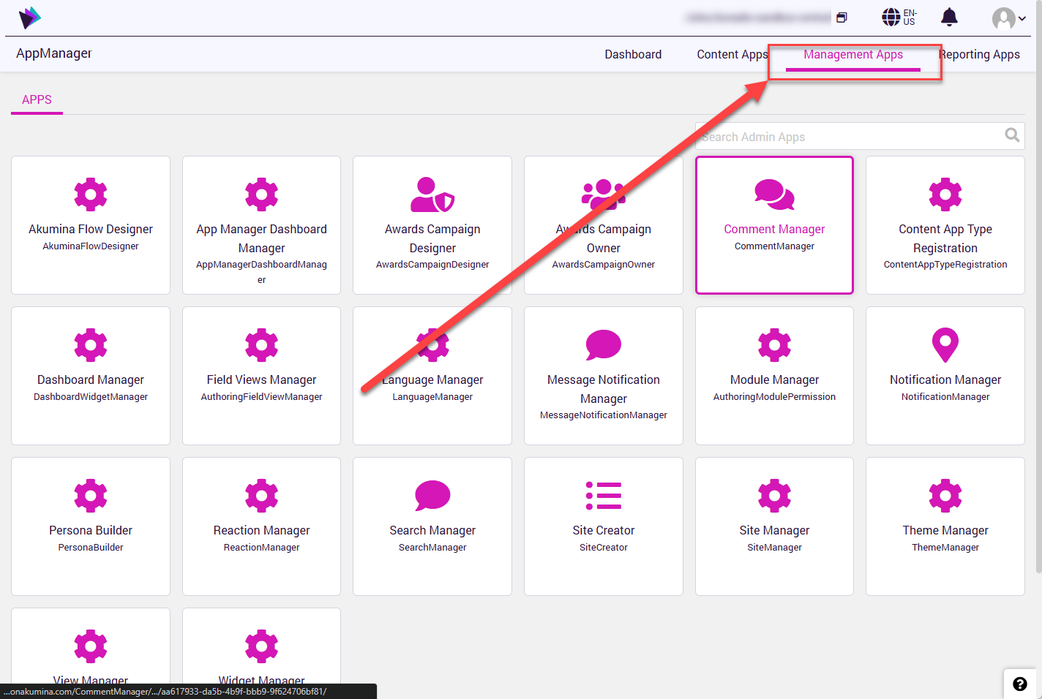
- Click on the Widget Manager button that appears on Management Apps tab.
- You will see a screen resembling the one below. Click on the CACHE WIDGET INSTANCES button that appears:
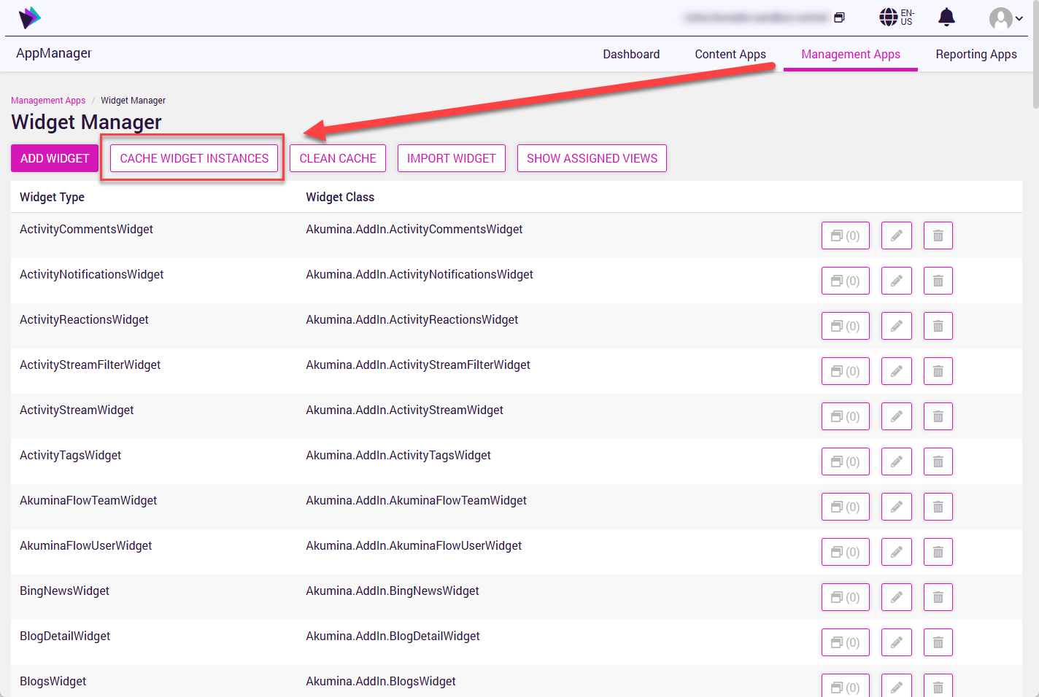

Step 2. Cache delivery site widget instances
The next step in the post-deployment checklist of steps is to ensure that the widget instances that are associated with the delivery site are cached. Follow the instructions outlined for Step 1.2 (above), but instead of selecting the central site, ensure that the delivery site is selected prior to clicking the CACHE WIDGET INSTANCES button.

Step 3. Cache delivery site pages
Much like the widgets mentioned in the previous two steps, it is oftentimes necessary to clean an Akumina delivery site’s page cache and then repopulate that cache for changes to become available. To execute this process, perform the following:
- Go to the Akumina App Manager, and make sure that you have the target delivery site selected.
- Select the Managements Apps tab.
- Select the Page Manager button on the page. This will open the Page Manager as shown below.
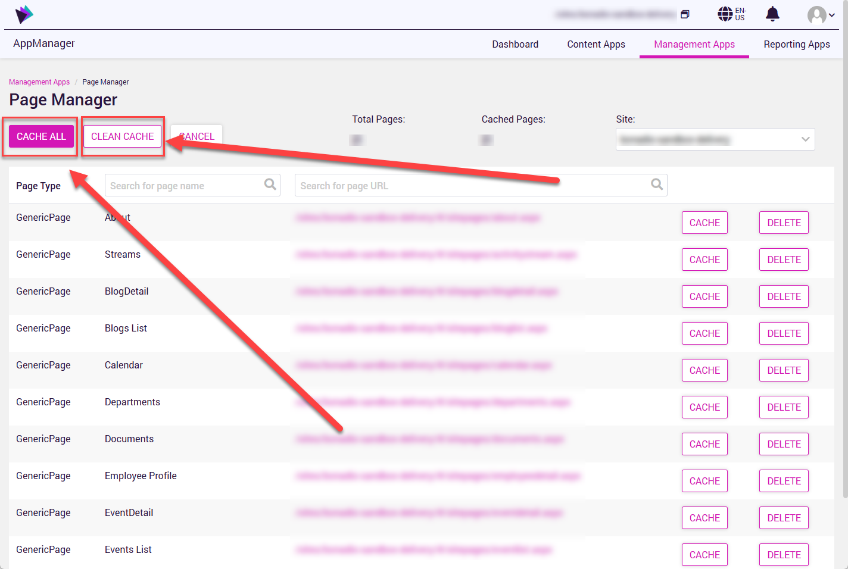
- Once the Page Manager appears, click its CLEAN CACHE button.
- After you’ve cleaned the page cache, click the CACHE ALL button.
Note that this process of re-caching pages could take anywhere from a handful of seconds to several minutes, depending on the number of pages being cached.

Step 4. Assign Akumina virtual master page and theme (optional)
This step is typically only needed upon initial site deployment or when changing an implemented theme or virtual master page. These settings are only available to headless site managers, and once set, they typically do not need to be re-established.
This step is marked as optional, and Akumina will direct you whether or not to perform this step.
To assign a virtual master page and/or theme, follow the outlined steps below:
- For the sake of illustration, let’s assume that your headless web front-end site is accessed through the following URL – https://xyzcorp.onakumina.com.
- There is no navigational or menu element out-of-the-box (OOTB) that will allow you to reach the site settings page, so you will have to modify the URL directly in your browser’s address bar by appending /admin/sitesettings to your headless front-end URL. In our example, we would modify the URL to in the browser address bar to read https://xyzcorp.onakumina.com/admin/sitesettings.
Access to the three common headless admin control pages (formed from the headless URL and the following path segments: ../admin/debug, ../admin/configsettings, and ../admin/sitesettings) are permissioned differently from other admin surfaces.
- Navigate your browser to the page at the modified URL/address. You should see something resembling the following:
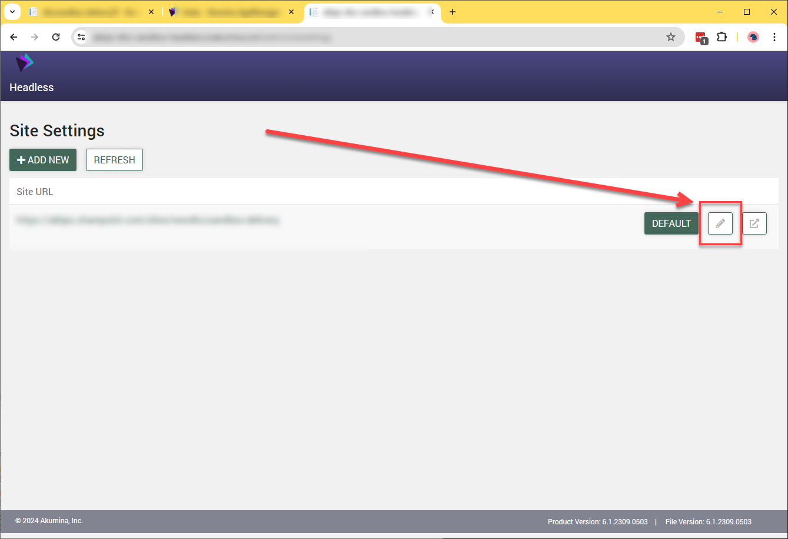
- Once on the Site Settings page, click the pencil icon next to the site marked as DEFAULT, and you will see the following page:
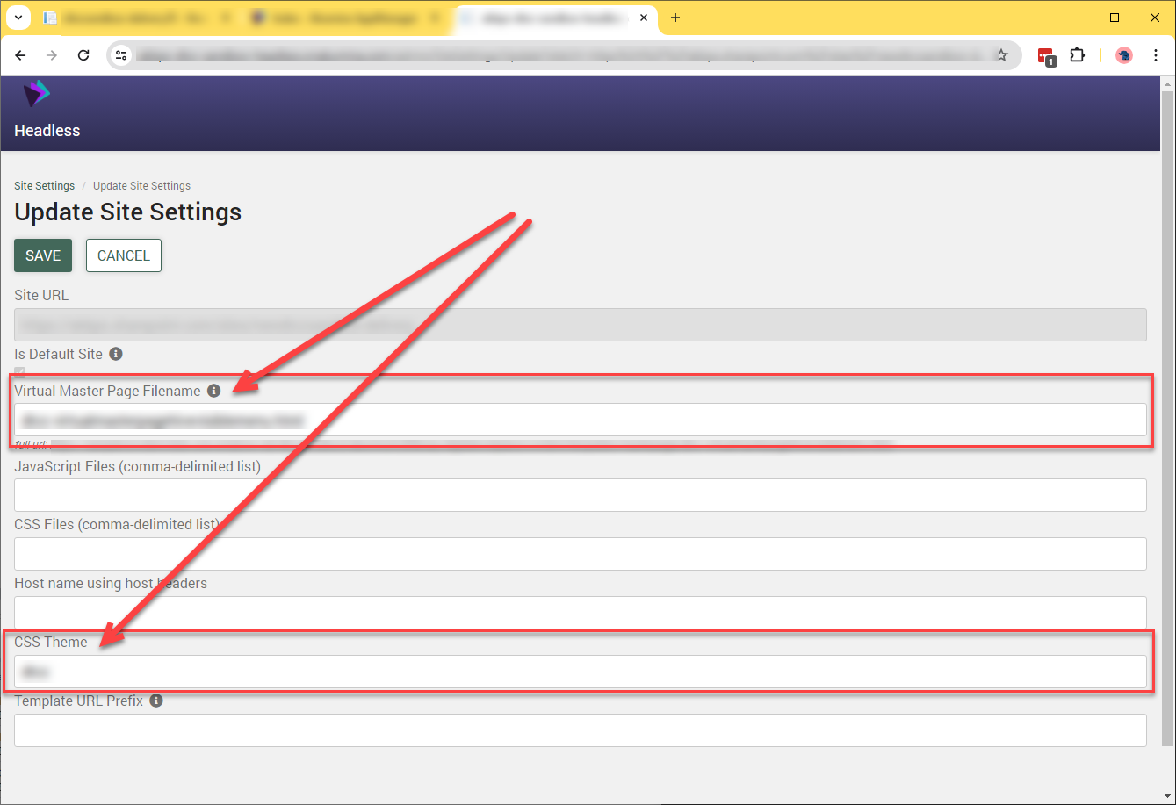

- Update the Virtual Master Page Filename and/or CSS Theme as instructed by Akumina.
- Click the SAVE button.

Step 5. Update central site configuration (optional)
This step is commonly performed anytime configuration changes are introduced, such as the introduction of new tokens or token files, new language-neutral lists, etc. Following an Akumina deployment that involves known configuration additions or modifications, we recommend the execution of this step to ensure that the runtime environment is up-to-date and in-sync with settings that may have been introduced.
This step is marked as optional, and Akumina will direct you whether or not to perform this step. Unless explicitly indicated, don’t perform this step.
To carry out a central site update, perform the following steps:
- Open the Akumina App Manager and ensure that the central site is selected.
- Navigate to the Management Apps tab.
- From the Management Apps tab, select the Site Creator button as seen below:
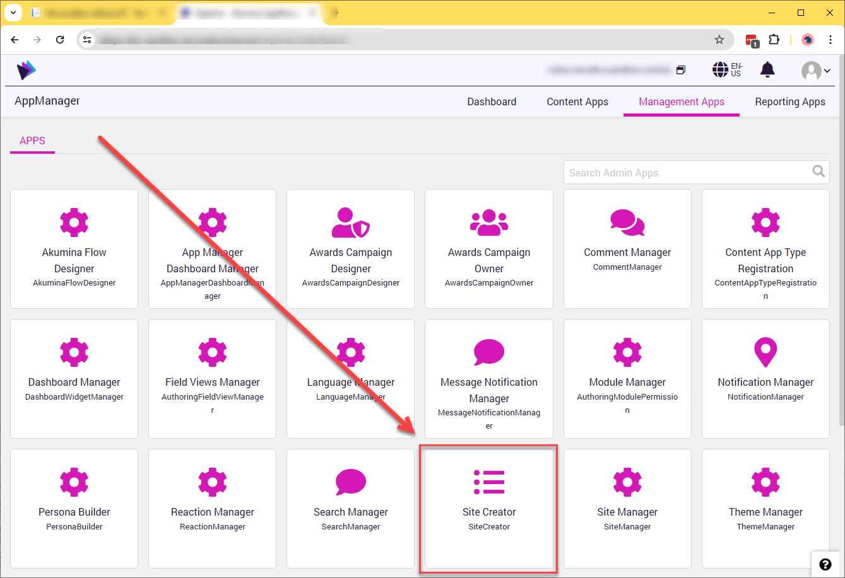

- Once inside the Site Creator, a single Select Site drop-down combo-box will be displayed, and it will likely (but not always) have only one entry: Digital Workplace Core Site:

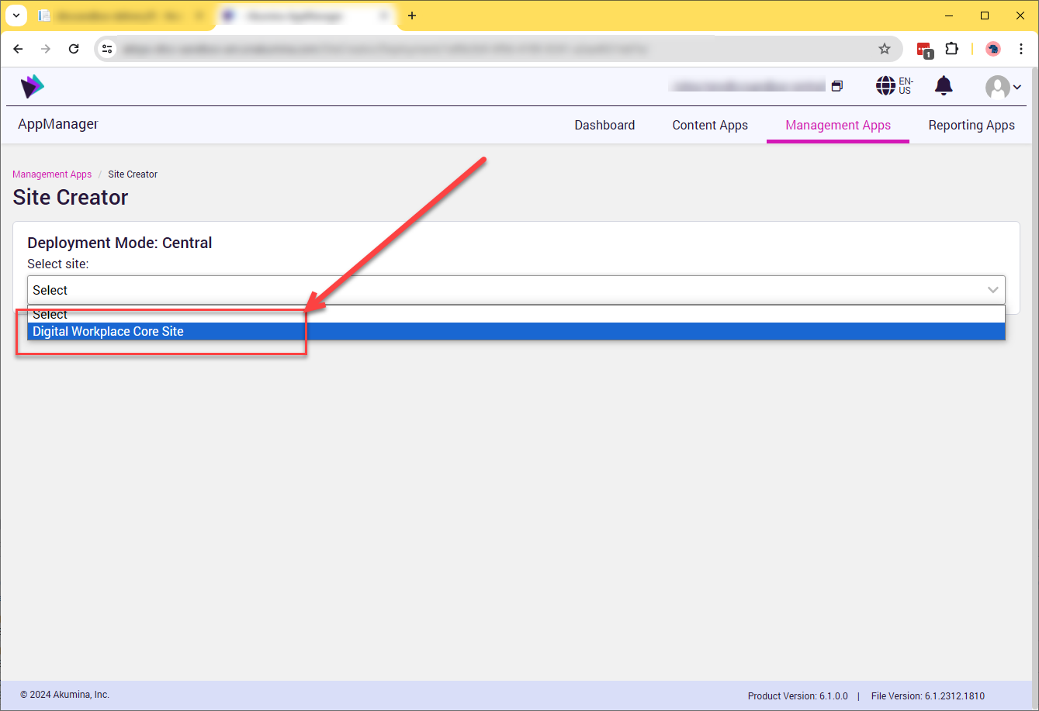

- Upon selecting Digital Workplace Core Site in the drop-down combo-box, the Site Creator page will populate with various settings and controls. At this point, select the option button that reads Update Configuration Settings as shown below:

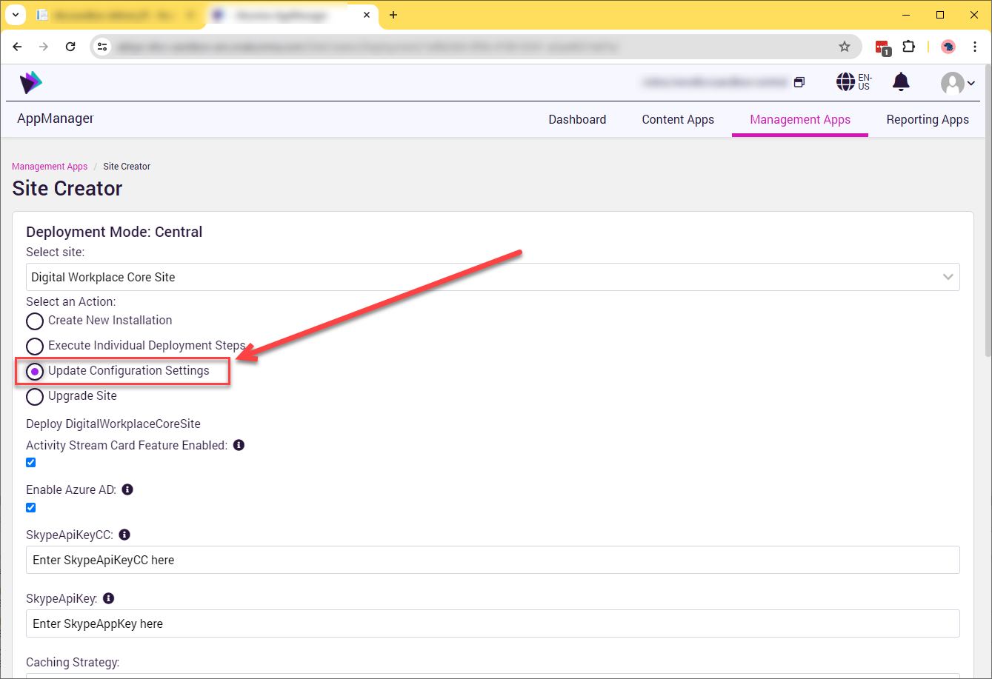

- With the Update Configuration Settings option selected, navigate to the bottom of the Site Creator page and press the UPDATE button as shown below:

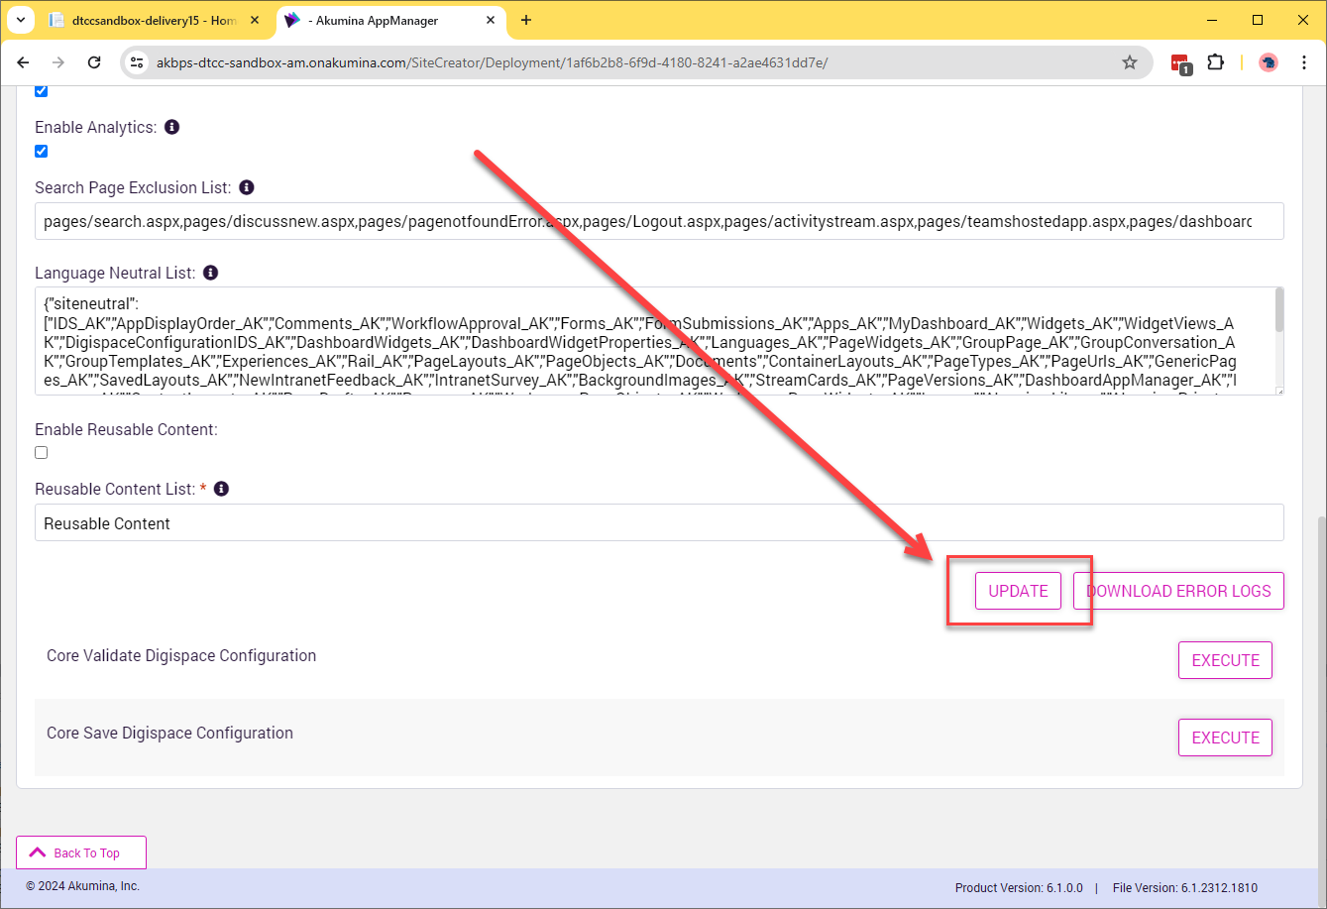

Step 6. Refresh the headless site cache
Following any Akumina deployment, we recommend clearing a couple of different caches where stale contents may exist. Without clearing these caches, your site may not reflect changes or new additions that were introduced by the deployment.
The first of the caches that needs to be cleared and repopulated is the headless site cache. Follow these steps to perform the headless cache clear and subsequent refresh:
- As with Step #4 (Assign Akumina virtual master page and theme), clearing the cache begins with the headless URL for your Akumina environment. To that URL, as it presents in the browser address bar, add /admin/debug. If our headless URL were https://xyzcorp.onakumina.com, we would modify the URL in the address bar to point at https://xyzcorp.onakumina.com/admin/debug.
- Upon navigating to the modified URL/address, you will see a page similar to the one that follows. When you do, click the CACHE tab:

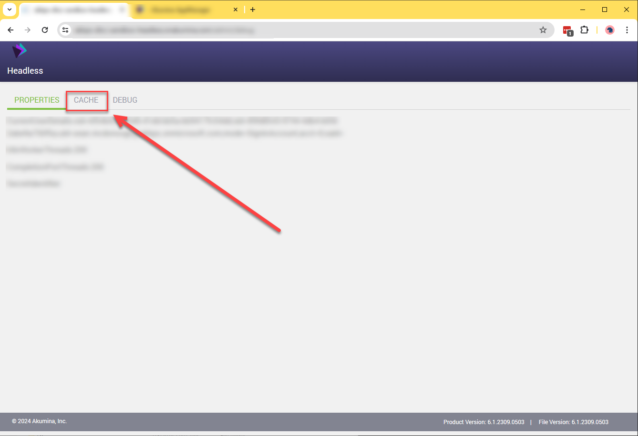

- Upon clicking the CACHE tab, you will see the page with three buttons illustrated below. Click the CLEAR CACHE button.

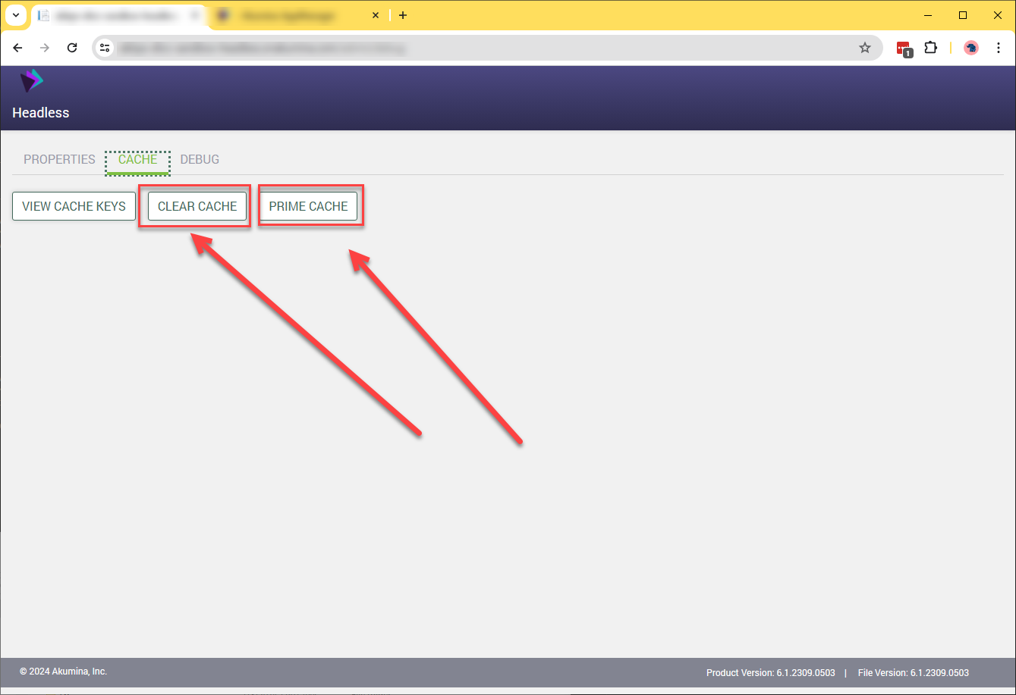

- After a very short time, click the PRIME CACHE button to populate the headless site cache with fresh content.

Step 7. Clear the AppManager cache (if directed by Akumina)
For most routine deployments, taking special steps to clear the AppManager’s various caches simply takes extra time and isn’t needed. In certain circumstances, however, you may be instructed to clear the AppManager-based caches maintained on the server side of the connection.
If you are instructed to clear your environment’s AppManager caches, follow these instructions:
- Ensure that you are in the Akumina AppManager for the appropriate environment and/or delivery site.
- Navigate your browser to the App Manager URL for your environment.
- Once in the AppManager, add /admin/debug to the end of the browser address bar and press <ENTER> to navigate to the AppManager debug page:
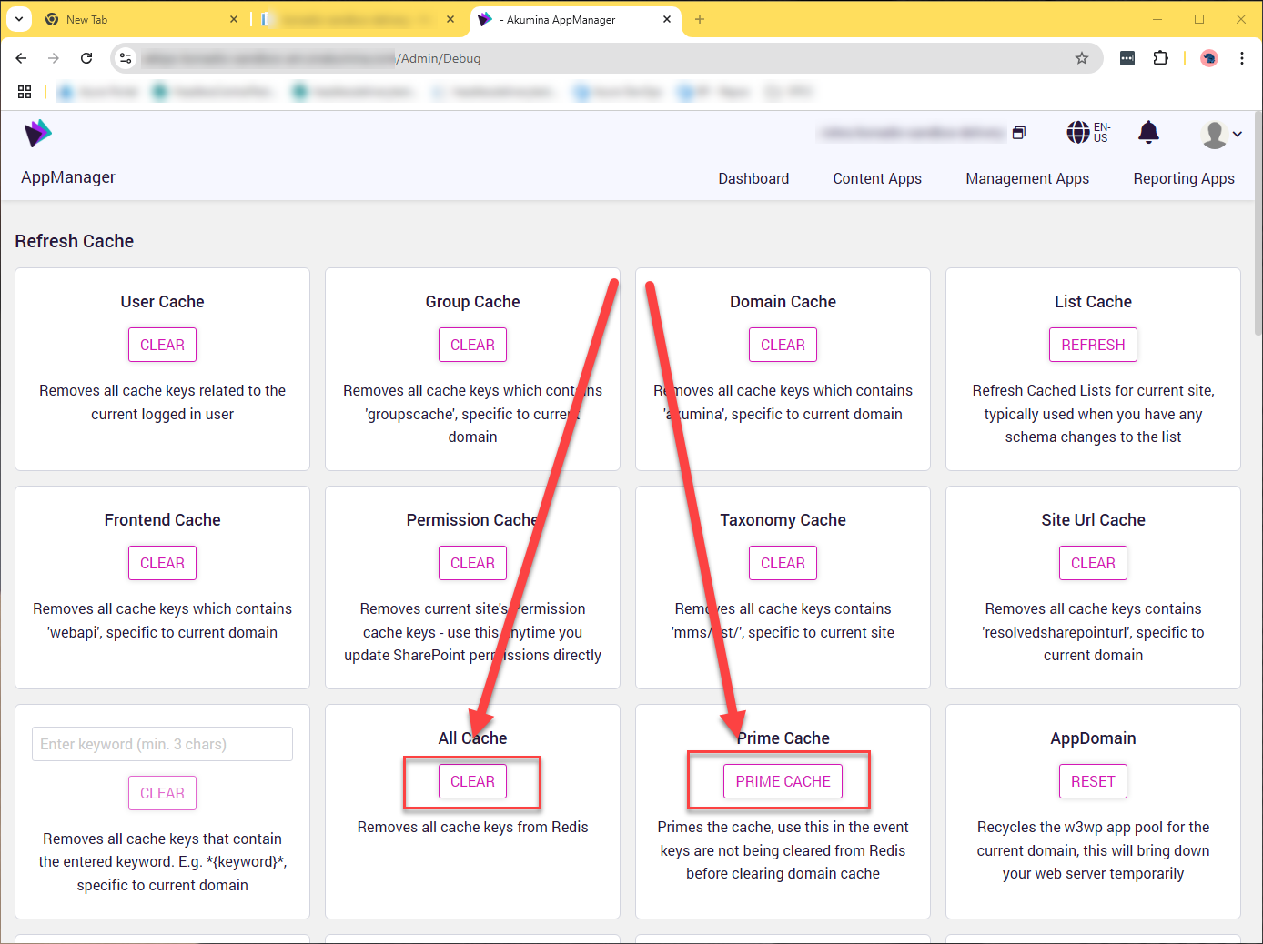
- Once on the Refresh Cache page (shown above). Click the CLEAR button for the All Cache entry.
- Next, click the PRIME CACHE button in the Prime Cache area to subsequently start repopulating the server-side cache with freshly retrieved data.
You are finished in the AppManager at this point. The browser window may be closed.

Step 8. Clear local browser cache
The other cache that should be cleared following any deployment, configuration, or file update is the local browser cache. The easiest way to do this is to follow the procedure documented below.
- Navigate to the delivery site of interest via the headless front-end endpoint.
- Expand the left-hand Akumina rail by clicking on the rail expansion button seen below:

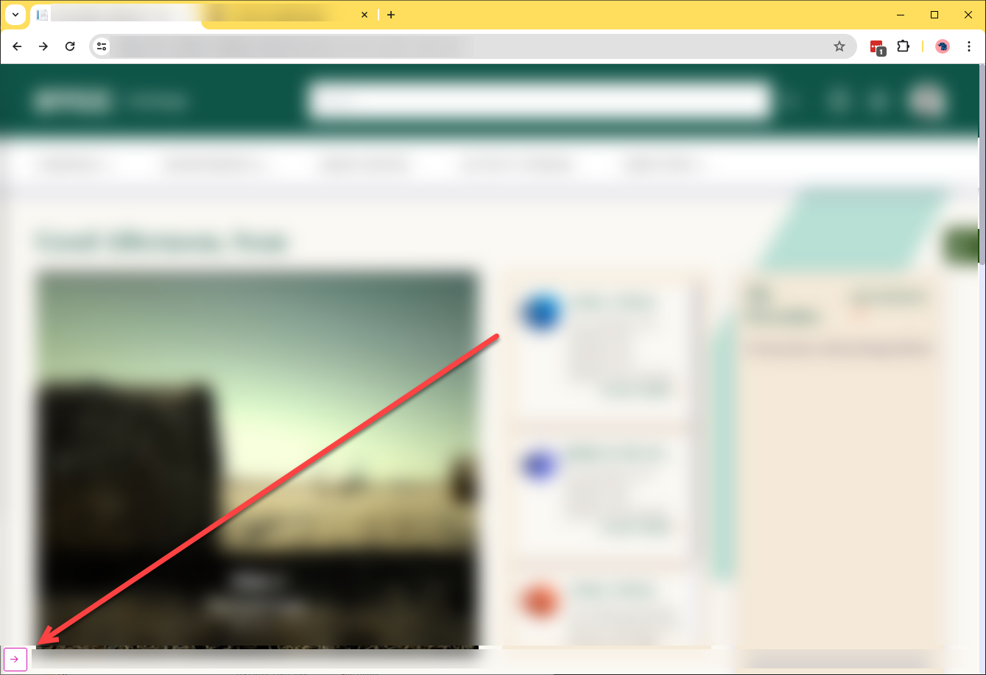

- Click the debug icon (it looks like a small bug) as shown below:

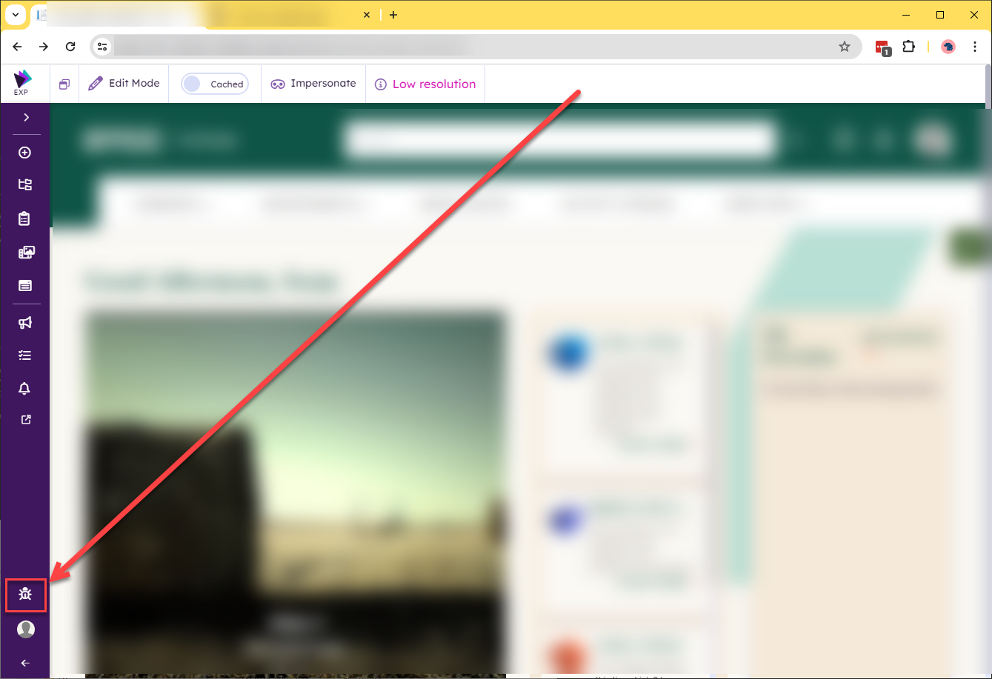

- The Akumina debug panel will open as shown below. When it does open, click on the Refresh Cache button next to the All Cache label:

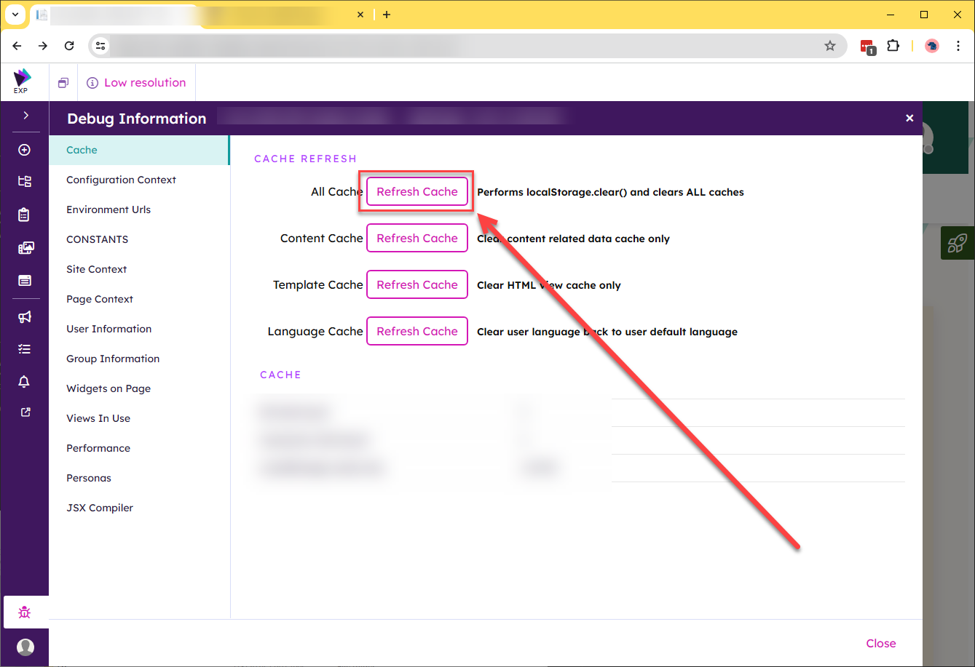

- Your local browser cache is now clear (i.e., localStorage has been cleared).
Note: A quicker way to reach the debug panel is by replacing steps two and three (above) with the keyboard shortcut <CTRL><↑> (i.e., the control key along with the arrow up key). This keyboard shortcut will take you directly to the debug panel.

Step 9. Perform a “hard refresh” to retrieve the headless site home page
The final step in the post-deployment series of steps is to perform a “hard” page reload. This can be accomplished in multiple ways, depending on the browser in use and your underlying operating system:
- On Windows machines, <CTRL><F5> will perform a hard refresh in all major browsers.
- For Macintosh systems, review available options at https://www.gavel.io/resources/what-is-a-hard-refresh-how-to-do-a-hard-refresh-in-any-browser.

Step 10. Enjoy your updated site!

